Trax is a puzzle game that presents the player with a problem to overcome before elevating to a higher level.

How you resolve this problem will depend greatly on what bonuses and tiles you have available for the round.

The problem Trax presents is simple, and can be taken into many other contexts to become solve-able.

For example, let’s imagine for a moment that the Trax grid is one large square river with a strong current pulling directly south and that the two opposite charge balls are two different tribes of people completely unable to get along with each other – if they meet there will surly be bloodshed between them both resulting in their immediate deaths – but also if any of them fall in the water they will sink and die.

You are Moses and you have to help the two tribes safely cross the river – but the game master (God) only cares for lives saved, and the number of killed gets pushed under the rug – once the quota of people are across the river; God will be pleased and reward you with powers of manipulation that are in alignment with his to continue helping the two factions cross the river.

As Moses you must see here that to play Trax you must realise there is no opposite faction in the eyes of God; that neither could exist without the other - god only sees one thing, wholeness and divinity between the two factions.

But God does register that although people, they are people with different paths.

One last thing to keep in mind, leading people down the wrong path’s that they are destined to go will result in penalty from God.

So, what are the flaws in this social moral God runs his shift under? Well for one, we can see differences between the two factions of people and we could choose to save one – and sink the other in the river – remember God does not care for lives lost but only lives saved and as long as you do not alter the paths they are destined to go; God will be pleased.

With the tiles you have available for the round you will be looking at re-producing either of these structures to the best of your ability with the limitation of the tiles on the grid; these two examples below are called the Funnel Method’s.

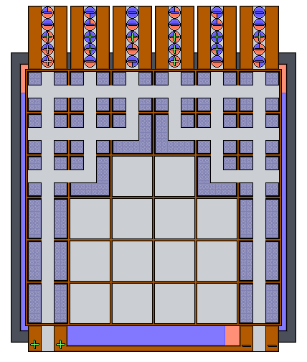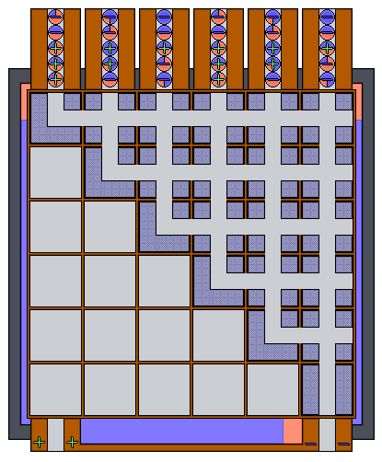
Funnel Method 2 Funnel Method 1

These methods are pretty self-apparent, but if you still don’t get it then what you basically working to do is funnel all the balls into one goal or funnel some balls into one goal and some balls into the other.

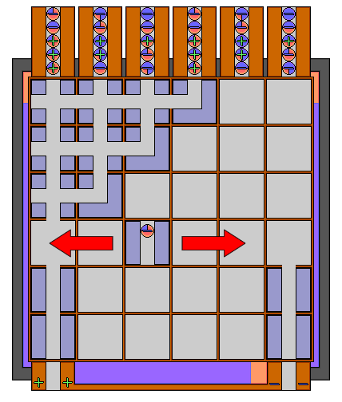

There’s also another method you’ll want under your belt and that’s called Switching.

Switching is where you use the ability to move tiles from left to right in the grid while retaining the ball inside; using this method you can make switches in your ‘Trax’.

